Main Interactive Menu and Add New Item  
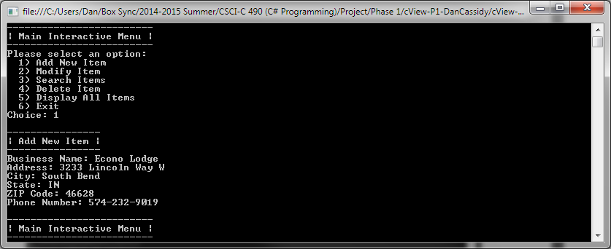

Cancelling and then attempting invalid input in Modify Item  
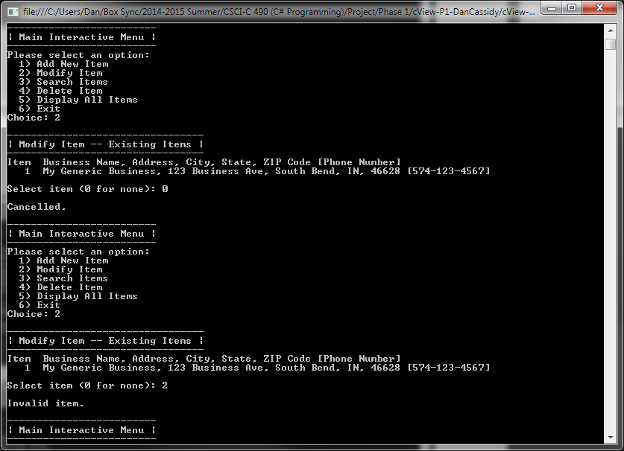

Modify Item and Modify Item Menu  
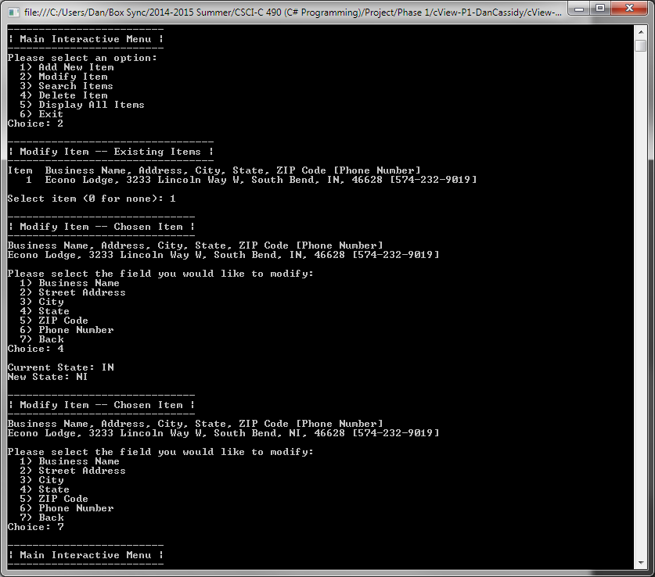

Searching and items found  
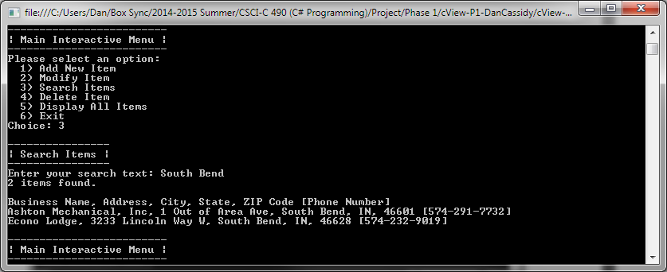

Searching and no items found  
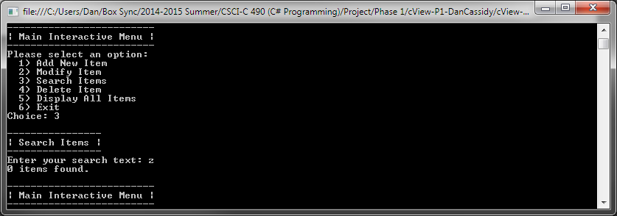

Display All Items (Pre-Delete)  
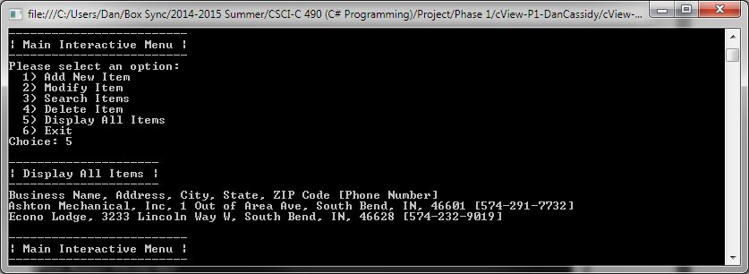

Cancelling and then attempting invalid input in Delete Item  
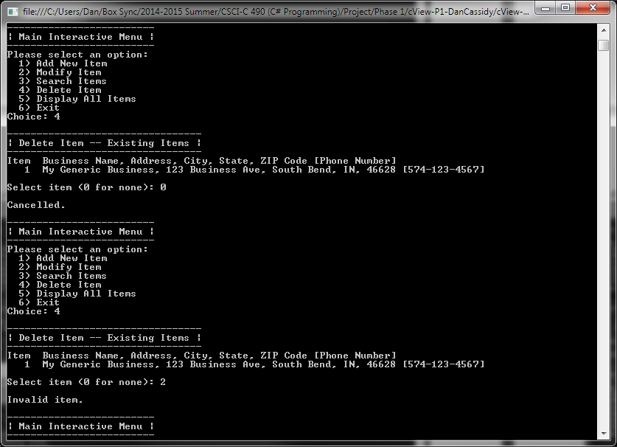

Delete Item  
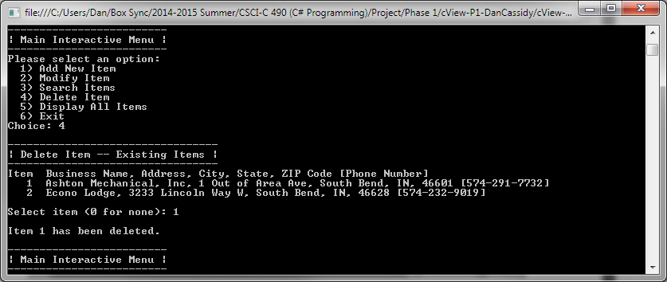

Display All Items (Post-Delete)  
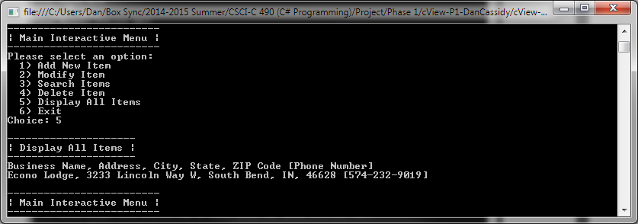

Attempting to modify an item when empty.  
